Teamfight Tactics Team Composition Analysis and Prediction

Names of participants:

* Oliver
* Kacie Li
* Yuxuan Qiu

**Objective and Motivation**

**Objective:** This study endeavors to construct a predictive model designed to forecast game outcomes by analyzing player builds (units, traits and augments) in the game Team Fight Tactics. The primary objective is to equip players with the knowledge and strategies necessary to secure a first-place finish or a position within the top four contenders in the game, thereby enhancing their overall gaming experience and competitive performance.

**Motivation**: The driving force behind this endeavor is to unravel the pivotal secrets necessary for achieving victory in Teamfight Tactics. With the game presenting players with an abundance of options at every turn, each choice carrying the potential to significantly impact the outcome, there exists a compelling need to delve deeper into the strategic intricacies of the game. By understanding the diverse array of choices available to players and the unique ramifications of each decision, this research seeks to illuminate the pathway to success in Teamfight Tactics, offering invaluable insights into the complex dynamics that govern optimal gameplay strategies.

**Data**

We will be gathering data from the Riot Developer API. We will get summoner IDs from the Grand Master league, use those to find match histories, and then gather data about team compositions and their respective placements from those individual matches. Finally we will aggregate this data into a sparse data frame where our features are the various Units, Augments, and Traits that make up one’s team composition and our target variable will be match placement.

**Feature Variables**

Traits

Augments

Units

**Target Variable**

Position (1st - 8th)

**Methods Overview**

We will visualize and analyze the data based on usage and win rate. For example, we will visualize the team compositions that have the highest win rates, or the positions of the best team compositions. The positions are the placements of the player, 1 through 8, where 1 is the first place, and the top four players are considered the winners. The team compositions include the combinations of units, augments, and traits that the player has. Through these analyses we expect to see which team compositions are considered most powerful and see common trends among the top team compositions.

We will use bar charts and visualize distributions to analyze the proportion of usages of various team comps. This would open the initial analysis and evaluation of current gameplay, and establish the idea and reason behind results and research. More specifically, we can look at which champions are most used, and which traits and augments are most used.

Additionally, we will use PCA to analyze the data and try to find any patterns and the reason for those patterns. We will also look at correlation between the different aspects of the team comps, and what aspect of team comps weigh the most on victory. The plot below shows our initial analysis for PCA. We plan on expanding our PCA analysis by looking at explained variance, using a latticed plot with more components, and adding in the loadings to the plot.

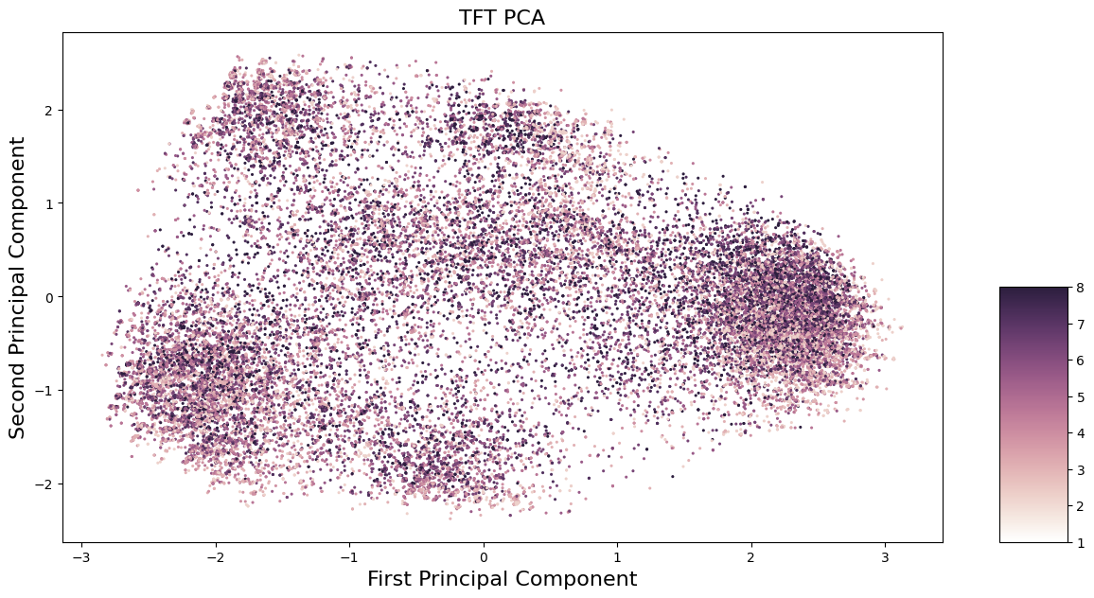

We will use Python to access and visualize the data. We plan to use various Python libraries, including but not limited to NumPy, Pandas, and Matplot. Python will also be used to access the data through the API, as well as for data cleaning and data processing.